**UDYOG SAARTHI**

## A PROJECT REPORT

***Submitted by,***

**RAHUL YADAV . B - 20211CSE0321**

**MOHANA RANGA. T - 20211CSE0503**

**SHAIK IRFAN - 20211CSE0734**

**BHARATH REDDY. B - 20211CSE0779**

**TEJESH REDDY D.V - 20211CSE0769**

### *Under the guidance of,*

**Dr. KUPPALA SARITHA**

***in partial fulfillment for the award of the degree of***

**BACHELOR OF TECHNOLOGY**

**IN**

**COMPUTER SCIENCE AND ENGINEERING**

**At**



**PRESIDENCY UNIVERSITY**

**BENGALURU**

**APRIL 2025**

**PRESIDENCY UNIVERSITY**

**SCHOOL OF COMPUTER SCIENCE ENGINEERING**

**CERTIFICATE**

This is to certify that the Project report **“UDYOG SAARTHI”** being submitted by “RAHUL YADAV.B, MOHANA RANGA.T, SHAIK IRFAN, BHARATH REDDY.B, TEJESH REDDY” bearing roll number(s) “20211CSE0321, 20211CSE0503, 20211CSE0734, 20211CSE0779, 20211CSE0769” in partial fulfillment of the requirement for the award of the degree of Bachelor of Technology in Computer Science and Engineering is a Bonafide work carried out under my supervision.

|  |  |
| --- | --- |
| **Dr. KUPPALA SARITHA**  Professor  School of CSE&IS  Presidency University | **Dr. ASIF MOHAMMED**  Associate Prof.& HoD  School of CSE&IS  Presidency University |

|  |  |  |
| --- | --- | --- |
| **Dr. L. SHAKKEERA**  Associate Dean  School of CSE  Presidency University | **Dr. MYDHILI NAIR**  Associate Dean  School of CSE  Presidency University | **Dr. SAMEERUDDIN KHAN**  Pro-Vice Chancellor  School of Engineering  Dean -School of CSE&IS  Presidency University |

**PRESIDENCY UNIVERSITY**

**SCHOOL OF COMPUTER SCIENCE ENGINEERING**

**DECLARATION**

We hereby declare that the work, which is being presented in the project report entitled **UDYOG SAARTHI** in partial fulfillment for the award of Degree of **Bachelor of Technology** in **Computer Science and Engineering**, is a record of our own investigations carried under the guidance of **Dr. Kuppala Saritha,** **School of Computer Science Engineering, Presidency University, Bengaluru.**

We have not submitted the matter presented in this report anywhere for the award of any other Degree.

|  |  |  |  |  |  |
| --- | --- | --- | --- | --- | --- |
| **Students Name**  RAHUL YADAV  MOHANA RANGA  SHAIK IRFAN  BHARATH REDDY  TEJESH REDDY |  | **Roll Numbers**  20211CSE0321  20211CSE0503  20211CSE0734  20211CSE0779  20211CSE0769 | **Signatures** | |  |
|  |  |  | |  |  |

**ABSTRACT**

The Udyog Saarthi App is a progressive web-based application designed to empower adults with disabilities by providing them with crucial resources and support in their job search efforts. In light of the increasing focus on inclusivity and equal employment opportunities, this initiative specifically addresses the challenges faced by individuals seeking employment under the 4% reservation policy in institutions such as the National Institute for Empowerment of Persons with Multiple Disabilities (NIEPMD). This abstract outlines the app's objectives, features, significance, and potential impact on enhancing employability among persons with disabilities.

Despite advancements in legislation and policies aimed at promoting inclusivity, individuals with disabilities often encounter significant barriers in securing employment. The 4% reservation policy is a vital component of India's commitment to ensuring that persons with disabilities have access to government jobs. However, many potential candidates remain unaware of their rights and the resources available to them, leading to underutilization of these opportunities. The Udyog Saarthi App was developed in response to this critical need, providing a comprehensive platform that combines job coaching with information dissemination regarding available employment opportunities.

Through features like AI-based personalized job matching, accessibility-first design, and employer engagement modules, the app significantly enhances the employability and career growth prospects of its users. Additionally, it fosters long-term workforce inclusion by providing post-placement support and career development tools.

This initiative not only improves individual employment outcomes but also contributes to broader sustainable development goals, including quality education, decent work, and reduced inequalities. The Udyog Saarthi App represents an important step toward creating a more inclusive, diverse, and accessible employment landscape for persons with disabilities.

***Keywords:*** *Employment, Accessibility, Disabilities, Inclusion, Training, Awareness.*

**ACKNOWLEDGEMENT**

First of all, we indebted to the **GOD ALMIGHTY** for giving me an opportunity to excel in our efforts to complete this project on time.

We express our sincere thanks to our respected dean **Dr. Md. Sameeruddin Khan**, Pro-Vice Chancellor, School of Engineering and Dean, School of Computer Science Engineering & Information Science, Presidency University for getting us permission to undergo the project.

We express our heartfelt gratitude to our beloved Associate Deans **Dr. Shakkeera L and Dr. Mydhili Nair,** School of Computer Science Engineering & Information Science, Presidency University, and Dr. “**Dr. Asif Mohammed H.B**”, Head of the Department, School of Computer Science Engineering & Information Science, Presidency University, for rendering timely help in completing this project successfully.

We are greatly indebted to our guide **Dr. Kuppala Saritha, Professor** and School of Computer Science Engineering, Presidency University for her inspirational guidance, and valuable suggestions and for providing us a chance to express our technical capabilities in every respect for the completion of the project work.

We would like to convey our gratitude and heartfelt thanks to the PIP2001 Capstone Project Coordinators **Dr. Sampath A K, Dr. Abdul Khadar A and Mr. Md Zia Ur Rahman,** department Project Coordinators **Mr. Amarnath J.L & Dr. Jayanthi. K** and Git hub coordinator **Mr. Muthuraj.**

We thank our family and friends for the strong support and inspiration they have provided us in bringing out this project.

**Rahul Yadav**

**Mohana Ranga**

**Shaik Irfan**

**Bharath Reddy**

**Tejesh Reddy**

|  |  |  |  |
| --- | --- | --- | --- |
| **Sl. No.** | **Table Name** | **Table Caption** | **Page No.** |
| 1  2  3 | Table 3.1  Table 3.2  Table 3.3 | Research Gaps  Requirements  Features | 11  13  16 |
|  |  |  |  |

**LIST OF TABLES**

**LIST OF FIGURES**

|  |  |  |  |
| --- | --- | --- | --- |
| **Sl. No.** | **Figure Name** | **Caption** | **Page No.** |
| 1  2  3  4  5  6  7 | Figure 4.1  Figure 4.2  Figure 4.3  Figure 4.4  Figure 4.5  Figure 4.6  Figure 6.1 | Data flow Diagram  State Diagram  Class Diagram  Use case Diagram  Activity Diagram  Architecture Diagram  Gant Chart | 08  10  14  21  25  27  28 |

**TABLE OF CONTENTS**

|  |  |  |
| --- | --- | --- |
| **CHAPTER NO.** | **TITLE** | **PAGE NO.** |
|  | **ABSTRACT ACKNOWLEDGMENT** | **iv**  **v** |

1. INTRODUCTION 1 - 2
2. LITERATURE SURVEY 3 - 6
3. RESEARCH GAPS OF

EXISTING METHODS 7 – 14

1. PROPOSED METHODOLOGY 15 – 18
2. OBJECTIVES 19 – 21
3. SYSTEM DESIGN & IMPLEMENTATION 22 – 27
4. TIMELINE FOR EXECUTION OF

PROJECT (GANTT CHART) 28

1. OUTCOMES 29 – 31
2. RESULTS AND DISCUSSIONS 32 – 35
3. CONCLUSION 36
4. REFERENCES 35 – 36
5. APPENDIX-A (Code)
6. APPENDIX-B (Screenshots)

**CHAPTER-1**

**INTRODUCTION**

In recent years, the emphasis on inclusivity and equal opportunities for individuals with disabilities has gained significant momentum across various sectors. The Udyog Saarthi App emerges as a pivotal initiative aimed at empowering adults with disabilities by providing them with essential resources and support in their job search endeavors. This progressive web-based application is specifically designed to cater to individuals undergoing job coaching, particularly focusing on the opportunities available under the 4% reservation policy in institutions like the National Institute for Empowerment of Persons with Multiple Disabilities (NIEPMD).

The need for specialized employment support for individuals with disabilities is underscored by the challenges they face in securing jobs. Despite legislative frameworks and policies aimed at promoting inclusivity, many individuals remain unaware of their rights and the resources available to them. The 4% reservation policy is a crucial aspect of this landscape, ensuring that a specific percentage of government jobs are reserved for persons with disabilities. However, navigating the complexities of job applications, training programs, and employment opportunities can be daunting without adequate guidance and support.

Recognizing this gap, the Udyog Saarthi App aims to provide a comprehensive solution that not only informs users about their rights but also equips them with the necessary skills and knowledge to enhance their employability. By integrating job coaching into a user-friendly digital platform, the app seeks to bridge the divide between potential employees and available job opportunities.

By leveraging technology for social good, the Udyog Saarthi App stands as a testament to how digital platforms can be harnessed to promote inclusivity in employment. Its development reflects a growing awareness of the importance of accessible resources for marginalized communities and highlights the role of technology in facilitating meaningful employment opportunities.

The primary objective of the Udyog Saarthi App is to facilitate access to job coaching and employment resources for adults with disabilities. The app aims to achieve the following specific goals:

**Enhance Employability:** By offering tailored training modules and resources, the app seeks to equip users with essential skills that improve their employability in various sectors.

**Promote Awareness:** The app aims to raise awareness about job opportunities available under the 4% reservation policy, ensuring users are informed about their rights and options.

**Foster Community Support:** By creating a platform for users to connect and share experiences, the app encourages peer support and collaboration among individuals facing similar challenges.

**Comprehensive Job Coaching:** The app provides access to a variety of resources focused on job preparation, including resume writing tips, interview techniques, and soft skills development. These resources are tailored specifically for individuals with disabilities, addressing their unique challenges in the job market.

**Information on Reservation Opportunities:** Users can easily access information about job openings that fall under the 4% reservation policy, including government positions and self-employment schemes. This feature ensures that users are aware of their rights and can take advantage of available opportunities.

**User-Friendly Design:** As a progressive web application, Udyog Saarthi is designed for accessibility across multiple devices. Its intuitive interface allows users to navigate seamlessly through various sections without technical difficulties.

**Community Engagement:** The app fosters community engagement through forums or discussion groups where users can share insights, seek guidance, and support one another in their job search journeys.

The Udyog Saarthi App reimagines disability employment support by merging policy awareness, skill development, and technology. By addressing the "last mile" challenges in the 4% reservation system, it has the potential to transform inclusivity in India’s workforce.

At the core of the Udyog Saarthi App is the creation of a comprehensive learning profile for each user. This profile captures essential information such as the user’s Unique Disability ID (UDID), literacy level, skills training, address, functional difficulties (as per the Washington Group Extended Set Questions), assistive devices used or required, human assistance needs, and career aspirations. By maintaining such detailed records, the app ensures that job recommendations and training resources are tailored to each individual’s specific needs and goals.

**CHAPTER-2**

**LITERATURE SURVEY**

The employment landscape for individuals with disabilities has evolved significantly over the past few decades, driven by legislative reforms, social awareness, and technological advancements. Despite these positive changes, individuals with disabilities continue to face substantial barriers in securing meaningful employment. This literature survey aims to explore existing research, applications, and methodologies that address the challenges faced by this demographic in the job market. It will also examine how digital platforms, such as the Udyog Saarthi App, can enhance job coaching and facilitate access to employment opportunities under reservation policies.

**Employment Challenges for Individuals with Disabilities:**

Research indicates that individuals with disabilities often encounter systemic barriers that hinder their access to employment. These barriers include negative employer attitudes, lack of awareness about disability rights, inadequate training programs, and limited access to job opportunities. A study by McDaid et al. (2019) highlights that despite legal frameworks like the Americans with Disabilities Act (ADA) in the United States and similar legislation in other countries, societal stigma and misconceptions about disability persist. This stigma often results in employers being reluctant to hire individuals with disabilities, leading to higher unemployment rates within this population. Moreover, a report by the World Health Organization (WHO) (2020) emphasizes that individuals with disabilities are disproportionately affected by poverty and social exclusion. This situation is exacerbated by a lack of tailored vocational training programs that address their unique needs. The absence of targeted support systems contributes to a cycle of unemployment and underemployment among individuals with disabilities.

**Reservation Policies and Their Impact:**

Reservation policies play a crucial role in promoting employment opportunities for individuals with disabilities. In India, the government has implemented various policies aimed at reserving a specific percentage of jobs for persons with disabilities in public sector employment. The Rights of Persons with Disabilities Act (2016) mandates a 4% reservation in government jobs for individuals with disabilities. Research conducted by Kumar et al. (2021) indicates that while these policies have improved access to government jobs, there is still a significant gap in awareness and implementation at the grassroots level. Despite these policies, many potential candidates remain unaware of their rights or the specific opportunities available to them. A study by Sharma and Gupta (2022) found that lack of information and guidance significantly hampers the ability of individuals with disabilities to secure employment under reservation schemes. This highlights the need for comprehensive support systems that not only inform individuals about their rights but also provide them with the necessary skills to navigate the job market effectively.

**Digital Applications as a Solution:**

The advent of digital technology has opened new avenues for supporting individuals with disabilities in their job search efforts. Various applications have been developed to provide resources, training, and networking opportunities tailored to this demographic. A review by Singh et al. (2023) explores several digital platforms designed to enhance employability among persons with disabilities. These applications often include features such as job listings, resume-building tools, interview preparation resources, and community forums where users can share experiences and advice. One notable example is the Job Access app developed in Australia, which connects job seekers with disabilities to potential employers while providing resources for both parties on how to create an inclusive hiring process. Similarly, platforms like Able Seeker facilitate connections between employers seeking diverse talent and job seekers with disabilities. The literature suggests that digital applications can significantly improve access to employment resources for individuals with disabilities. However, it is essential to ensure that these applications are designed with user accessibility in mind. A study by Johnson et al. (2021) emphasizes the importance of user-centered design principles when developing digital platforms for this population. Ensuring that applications are intuitive and easy to navigate can enhance user engagement and effectiveness.

**Case Studies of Successful Implementations:**

Several case studies highlight successful implementations of digital applications aimed at supporting individuals with disabilities in their job search efforts. For instance, the "Disability Employment Services" program in Australia has successfully utilized digital tools to connect job seekers with employers while providing ongoing support throughout the employment process. The program incorporates personalized coaching through online platforms, enabling users to receive tailored guidance based on their unique needs. Another relevant case is the "Project SEARCH" initiative in the United States, which combines classroom instruction with hands-on work experience for students with disabilities. The program utilizes digital tools to track progress and connect students with potential employers, demonstrating how technology can facilitate meaningful employment outcomes. These case studies underscore the potential impact of integrating digital solutions into employment support programs for individuals with disabilities. By leveraging technology effectively, organizations can enhance service delivery and improve outcomes for job seekers.

**Barriers to Digital Adoption:**

Despite the promising potential of digital applications in supporting employment for individuals with disabilities, several barriers hinder widespread adoption. Access to technology remains a significant issue; many individuals may lack reliable internet access or necessary devices to utilize these platforms effectively. A report by the International Telecommunication Union (ITU) (2022) highlights that digital divides persist globally, particularly among marginalized communities. Additionally, there may be resistance from both job seekers and employers regarding the use of digital tools for recruitment processes. Some employers may prefer traditional hiring methods due to unfamiliarity or scepticism about the effectiveness of digital platforms in connecting them with qualified candidates. Conversely, some individuals may feel overwhelmed by technology or lack confidence in using digital tools effectively. To address these barriers, it is essential to provide training and support for both job seekers and employers regarding the use of digital applications in recruitment processes. Educational initiatives aimed at enhancing digital literacy among individuals with disabilities can empower them to leverage technology effectively in their job searches.

**Future Directions:**

As society continues to advance towards greater inclusivity for individuals with disabilities, there is an urgent need for innovative solutions that address employment challenges head-on. Future research should focus on developing comprehensive frameworks that integrate digital applications into existing support systems while ensuring accessibility and usability. Moreover, collaboration between government agencies, non-profit organizations, educational institutions, and technology developers is crucial for creating holistic solutions that meet the diverse needs of individuals with disabilities in their pursuit of meaningful employment. In conclusion, while significant progress has been made in promoting employment opportunities for individuals with disabilities through reservation policies and technological advancements, challenges remain. The development of targeted digital applications like Udyog Saarthi holds great promise in bridging existing gaps by providing essential resources and support tailored specifically for this demographic. This literature survey provides an overview of existing research on employment challenges faced by individuals with disabilities while emphasizing the role of digital applications as a solution within this context.

Overall, literature underscores the app’s potential to transform employment outcomes for PwDs by integrating technology, policy awareness, and community support. While initial implementations show promise in reducing unemployment rates, longitudinal studies are needed to assess its long-term impact on economic independence and social inclusion. The Udyog Saarthi App exemplifies how targeted digital solutions can align with national disability frameworks to promote equitable workforce participation

**CHAPTER-3**

**RESEARCH GAPS OF EXISTING METHODS**

Occupational opportunities remain the essential means by which persons with disabilities gain autonomy while joining the societal framework. Under the Rights of Persons with Disabilities (RPwD) Act 2016 the Government of India established 4% job vacancies for persons with benchmark disabilities in government employment positions and educational institutions. The Udyog Saarthi App serves as a development which aims to connect job seekers with reserved positions under this reservation system.

The Udyog Saarthi App functions as a Progressive Web Application (PWA) which focuses on assisting job coaching adults with disabilities at institutions like NIEPMD and comparable establishments. The digital platform utilizes technological advantages to simplify career development stages while linking users to jobs via an accessible platform designed for enhanced usability.

Users find a simple interface in the app that creates connections between skilled employees and inclusive employers while it provided job-readiness resources and monitored individual development throughout coaching duration. Users benefit from web-based progressive framework accessibility which lets them access services through multiple devices irrespective of internet connectivity strength.

Through its approach the Udyog Saarthi App greatly improves vocational training while serving to deliver an inclusive economy which gives persons with disabilities equal chances to succeed and make meaningful contributions.

Limited Accessibility Compliance

Most job portals together with coaching tools fail to comply fully with WCAG (Web Content Accessibility Guidelines) accessibility standards. The platforms become unusable for people who have visual or auditory impairments together with those who struggle with cognitive or motor functions.

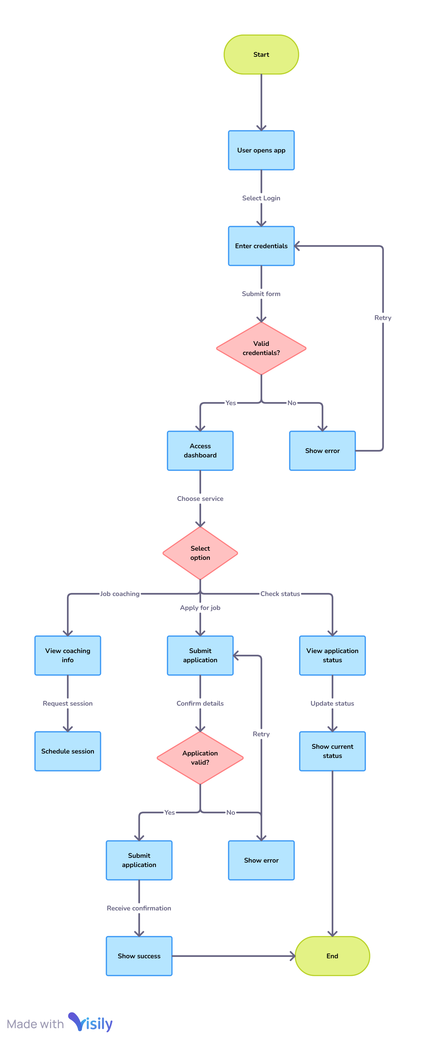

Data flow

**Fragmented Services:**

Job listing websites together with skill training platforms and existence of coaching services remain as separate systems instead of establishing an all-inclusive solution which joins testing with mentoring and personnel matching and learning evolution monitoring.

**Lack of Personalization:**

Existing career development methods adopt non-specific standard procedures that fail to adjust educational support and occupational suggestions toward personal abilities and interests and career aspirations of disability communities.

**Insufficient Employer Engagement:**

The majority of these platforms exclusively cater to job seekers while paying no attention to the employer development needed for better preparation. Workplace accommodations and diverse workforce value along with inclusion practices need more education about them among employers.

**Low Use of Emerging Technologies:**

Current job training models fail to maximize the effectiveness of Artificial Intelligence for targeted job placements together with virtual tutoring systems and adaptable education programs and employability data platforms.

**Inadequate Support for Remote or Rural Candidates:**

Job coaching services through various platforms neglect to serve candidates from distant locations since they encounter challenging obstacles including minimal internet access together with nonexistent physical coaching facilities as well as language barriers.

**Poor Follow-up and Long-term Tracking:**

Few companies provide any sustained follow-up services after employees get their first job to guarantee ongoing workplace retention. Most employment platforms in the market fail to monitor how former candidates with disabilities fare in their careers after placement along with their job satisfaction and workplace retention.

state diagram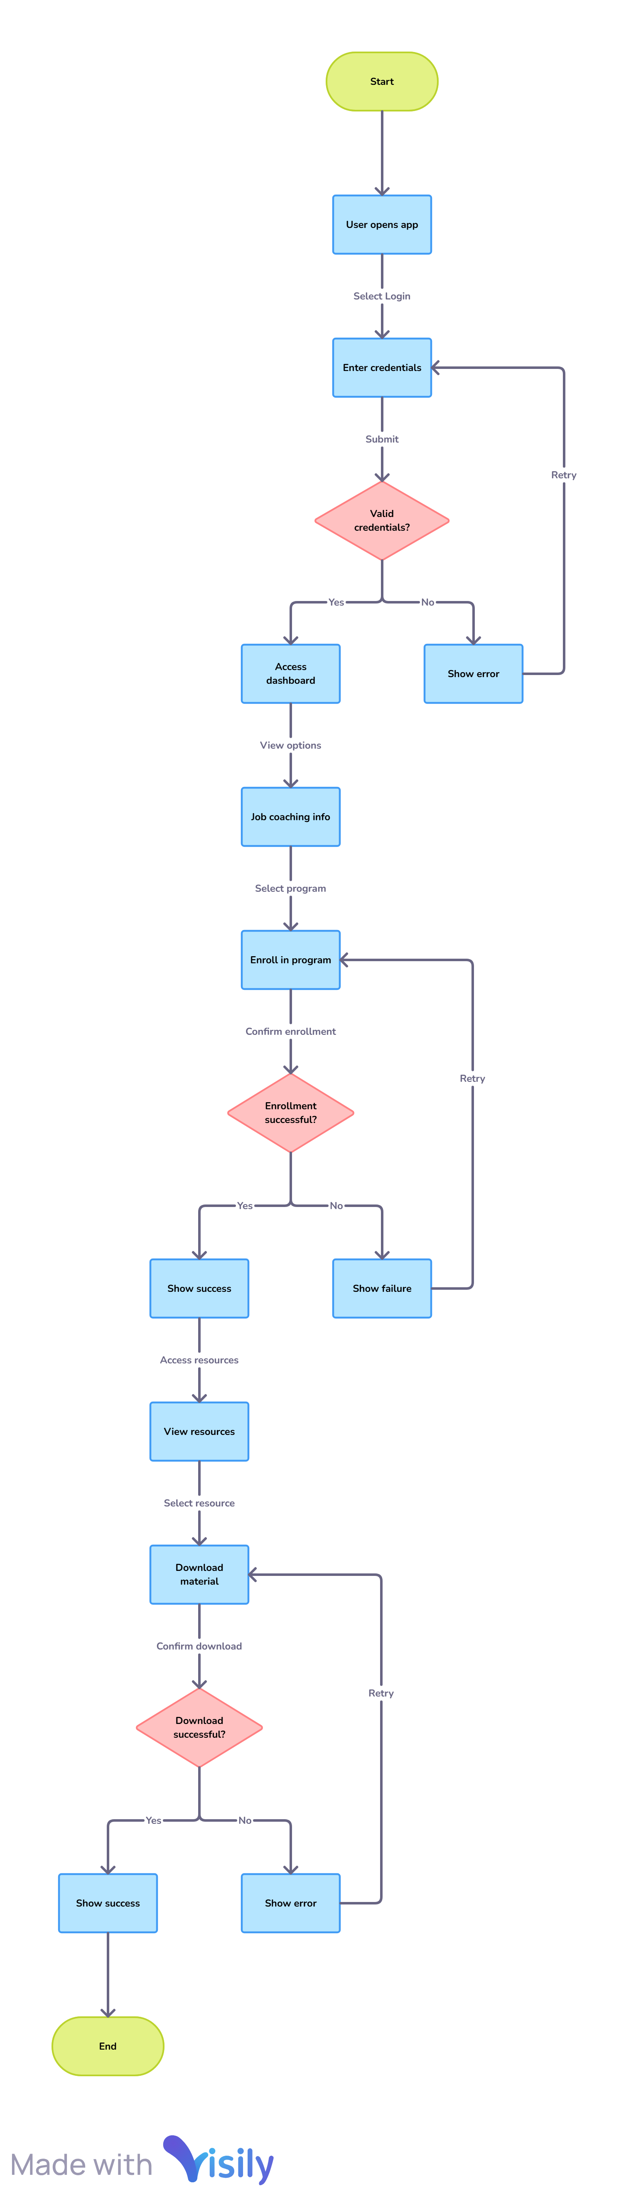

Too little data exists for crafting policies because research into this field remains insufficient.

The available databases lack comprehensive information about employment results achieved by persons with disabilities through current platforms. The information deficit inhibits effective improvements in policy creation and program delivery systems.

| **Gap Area** | **Description** |
| --- | --- |
| Task Analysis & Communication | Lack of individualized strategies and effective phasing out of job coach support |
| Assistive Technology | Low awareness, limited integration, cost/access barriers, lack of life-skill focus |
| Training & Follow UP | |  | | --- | | Inadequate user/provider training and ongoing support for assistive technology | |  | |
| Environmental Policy Barriers | |  | | --- | | Workplace attitudes, policy misalignment, and reimbursement issues | |  | |
| Life Stage Continuity | |  | | --- | | Fragmented support between education and employment, especially for late-onset disabilities | |  | |
| Digital Solution Integration | Absence of holistic, accessible, and personalized web-based job coaching platforms |

Table 3.1 Research Gaps

**Research Gaps:**

**1. Incomplete Task Analysis and Communication Strategies**

Job coaching practices currently fail to deliver customized task analysis suitable for different needs of adults who have intellectual disabilities and other impairments. Nonverbal clients along with those who retain information poorly often lack customized communication strategies due to which their integration at work becomes inconsistent.

Research studies about appropriate job coach withdrawal strategies are insufficient to meet the needs of supported employment success and ongoing independence.

**2. Limited Access and Integration of Assistive Technology (ATech):**

Very few employment support services currently integrate or show awareness toward assistive technology. The majority of services direct their clients toward external schemes such as Access to Work even though they fail to incorporate ATech training and usage into their own programs.

Currently there is no systematic approach for delivering ATech knowledge as a core life skill to disabled learners who need it for more than just academic and work activities. People develop insufficient confidence as well as inadequate familiarity with workplace technology which impairs their job search support and workplace adjustment capabilities.

The barriers to obtain ATech through cost and eligibility standards and lengthy procurement processes mostly affect individuals who have not yet started their paid employment.

**3. Insufficient Training and Follow-Up:**

The delivery of assistive technologies often includes insufficient user training with no sustainable support system to guarantee their sustained usage.

Medical service providers and employers fail to receive proper training about assisting technology which causes devices to become underutilized until they are abandoned.

**4. Environmental and Policy Barriers:**

Supported employment and job coaching face barriers because of environmental restrictions that include negative work attitudes and employer unawareness about disability as well as inflexible organizational policies.

Reimbursement policies and funding schemes follow rules over what would truly benefit users or offer the best assistance during work activities.

**5. Fragmented Support Across Life Stages:**

People with disabilities who acquire disabilities after finishing school often lack preparedness for employment support because they did not receive sufficient ATech support in their education.

Educational institutions (when support is provided) fail to sustain employment support initiatives because they disconnect services by removing resources and technology from students after graduation.

**6. Lack of Comprehensive Digital Solutions:**

Present digital coaching applications fail to create inclusive comprehensive solutions which deliver customized services required to assess skills before training users for employment then helping them remain in their jobs.

|  |  |  |  |
| --- | --- | --- | --- |
| **Component** | **Purpose** | **Key Features** | **Impact** |
| Job Coaching | Prepare users for employment | Resume building, interview training | Improved employability skills |
| Career Counseling | Guide career choices | Personalized plans, goal setting | Better career direction and confidence |
| Job Matching | Connect users with jobs | |  | | --- | |  |  |  | | --- | | AI-based skill-job alignment | | Higher placement rates |
| Accessibility Design | Ensure inclusive access | Screen reader, high contrast, easy UI | Independent platform usage |

Table 3.2 Requirements

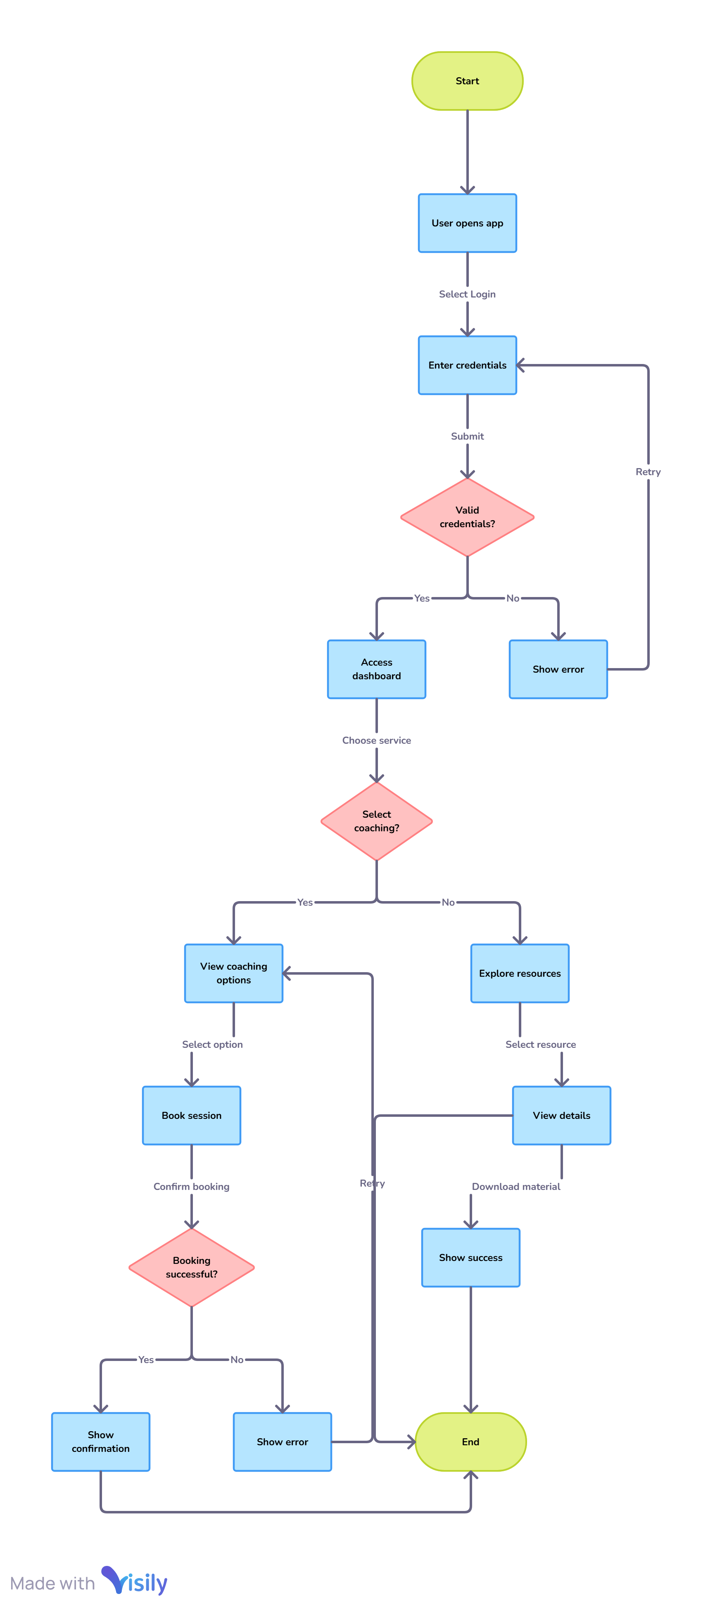

**Class diagram**

**CHAPTER-4**

**PROPOSED METHODOLOGY**

The Udyog Saarthi App is a digital solution aimed at addressing the challenges faced by adults with disabilities in accessing employment opportunities under the 4% reservation policy. The app is designed to provide job coaching, skill development, and access to curated job listings for Persons with Disabilities (PwDs). The primary objective of the app is to create an accessible and user-friendly platform that empowers PwDs by enhancing their employability and confidence. The app also aims to raise awareness about the 4% reservation policy and connect users with relevant opportunities. The scope of the app includes adults with disabilities, job coaches, and institutions implementing the 4% reservation policy, with a focus on accessibility, inclusivity, and ease of use.

**Research and Needs Assessment:**

The development of the Udyog Saarthi App began with comprehensive research and needs assessment phase. This phase involved identifying the key stakeholders, including adults with disabilities, job coaches, trainers, NIEPMD, government agencies, private employers, and disability rights organizations. A needs assessment was conducted through surveys and interviews with PwDs to understand their challenges in finding employment. The assessment revealed gaps in existing job coaching programs and digital tools for PwDs, highlighting the need for a centralized platform that combines job coaching, skill development, and job listings. A literature review was also conducted to study policies like the Rights of Persons with Disabilities Act, 2016, and the 4% reservation mandate, as well as best practices in accessible web design and job coaching for PwDs.

**Design and Development Approach:**

The design and development of the Udyog Saarthi App followed a user-centered design (UCD) approach to ensure the app meets the needs of its target users. This approach involved conducting usability testing with PwDs to refine the interface and features. Accessibility was a key focus during the design phase, with the app being developed to comply with the Web Content Accessibility Guidelines (WCAG) 2.1. Features such as screen reader compatibility, voice navigation, adjustable font sizes, and high-contrast themes were incorporated to ensure inclusivity. The technology stack for the app included HTML5, CSS3, JavaScript, and React.js for the frontend, Node.js and Express.js for the backend, and MongoDB for the database. The app was developed as a Progressive Web Application (PWA) using Lighthouse and Workbox to enable offline functionality and fast loading.

**Features and Functionality:**

The Udyog Saarthi App includes several key features designed to support adults with disabilities in their job search and skill development. These features include personalized job coaching sessions, skill development modules tailored to individual needs and abilities, and guidance on preparing for interviews, resume building, and workplace etiquette. The app also provides detailed information about the 4% reservation for PwDs in government and private sectors, along with updates on job openings and opportunities under this quota. Curated job listings from NIEPMD and other institutions are integrated into the app, with real-time notifications for new job postings and application deadlines. A resource library offers access to educational materials, videos, and guides on disability rights, workplace accommodations, and career growth. Additionally, the app includes tools for progress tracking, mentorship, and community support.

|  |  |
| --- | --- |
| **Benefit** | **How It Helps** |
| Easy Job Search | Centralized listings under 4% reservation |
| Skill Development | Enhances employability through targeted learning resources |
| Increased Job Placements | Smarter job matches based on user profiles |
| Accessibility for All Disabilities | Inclusive design ensures independent use |
| Long-term Career Growth | Support beyond placement for sustained employment |

Table 3.3 Features

**Implementation Strategy:**

The implementation strategy for the Udyog Saarthi App involved several key steps to ensure its successful deployment and adoption. A pilot test was conducted with a small group of PwDs and job coaches to gather feedback and iterate on the design and functionality. Training sessions were provided for job coaches and users on how to navigate the app, and user guides and video tutorials were created for easy onboarding. Partnerships were established with NIEPMD and other institutions to integrate their job listings and resources, and collaborations with disability rights organizations helped promote the app. The app was deployed on a secure cloud platform for scalability and reliability, and made available as a PWA, accessible via web browsers and installable on mobile devices.

**Monitoring and Evaluation:**

Monitoring and evaluation were critical components of the Udyog Saarthi App's methodology to ensure its effectiveness and impact. Key performance indicators (KPIs) were established to measure the app's success, including the number of registered users, active users, job application and placement rates, and user satisfaction scores. Data collection was conducted using analytics tools to track user engagement, feature usage, and job application rates. Periodic surveys and interviews with users were also conducted to assess the app’s impact. Continuous improvement was a focus, with regular updates to the app based on user feedback and changing needs. The app's impact on the employability and confidence of PwDs was measured, along with its contribution to raising awareness about the 4% reservation policy.

**Challenges and Mitigation Strategies:**

The development and implementation of the Udyog Saarthi App faced several challenges that required careful mitigation strategies. One of the primary challenges was ensuring widespread adoption among PwDs, especially in rural areas with limited internet access. To address this, the app was designed as a PWA with offline functionality, allowing users to access resources without an internet connection. Another challenge was maintaining up-to-date job listings and resources, which was addressed through partnerships with institutions like NIEPMD and regular updates to the app. Addressing diverse accessibility needs for users with different types of disabilities was also a challenge, and this was mitigated by incorporating a range of accessibility features and conducting usability testing with PwDs.

**Future Directions and Conclusion:**

The Udyog Saarthi App represents a significant step toward creating an inclusive and empowering ecosystem for PwDs. Future directions for the app include expanding its reach by partnering with more institutions and employers, introducing AI-based personalized coaching and job matching, and developing multilingual support to cater to a wider audience. Integration with government portals for seamless access to schemes and benefits is also a potential future enhancement. The app's development and implementation have demonstrated the potential of technology to bridge the gap between job seekers with disabilities and employment opportunities. By leveraging user-centred design, accessibility best practices, and evidence-based strategies, the Udyog Saarthi App aims to create a more inclusive and supportive environment for PwDs, helping them achieve their career

**CHAPTER-5**

**OBJECTIVES**

The fundamental goal of the Udyog Saarthi App targets to develop an inclusive digital platform which provides efficient support for adults with disabilities who receive job coaching. The app functions to solve the lack of connection between disability skill development and employment opportunities which are required by the 4% reservation specified in the Rights of Persons with Disabilities (RPwD) Act 2016. A Progressive Web Application framework in the app enables users to move among devices for seamless access to career resources and job coaching support and job applications despite any technical restrictions.

The system contains tools to boost job coaching quality by allowing ongoing candidate assessment and personal goal definition along with performance measurement capabilities. Through its platform NIEPMD and other training institutions become capable of delivering person-oriented guidance to each candidate through tailored recommendations based on strengths and career-specific requirements and personal interests. The app provides employers who promote inclusion alongside workplace preparedness material to help candidates transition into lasting meaningful jobs after securing employment.

Through the Udyog Saarthi App the program works to establish inclusive employer behavior by providing both employers and trained disabled candidates with a connection platform. The app supports inclusive workforce creation by providing employer outreach tools and employment awareness education and time-sensitive job fair alerts and recruitment information. The initiative achieves its alignment with national disability empowerment goals by establishing employment independence and social inclusion and dignity for people with disabilities.

**To Develop an Accessible Digital Platform:**

Our main goal is developing a Progressive Web Application (PWA) which complies with international accessibility standards to enable adults with different disabilities to use the platform without limitations.

**To Support Employment under the 4% Reservation:**

The Udyog Saarthi App establishes an interface which enables Persons with benchmark disabilities to access the job opportunities they are entitled to under Rights of Persons with Disabilities (RPwD) Act 2016 due to its 4% government and institutional placement objective.

**To Integrate Job Coaching and Career Services:**

The platform's main objective involves integrating job coaching functions together with career counseling and skills assessment followed by employment placement into one unified employment support environment for vocational trainees.

**To Personalize Career Guidance:**

Custom career guidance, skills development tools and personal job recommendations form the core features of this app because it avoids generic solutions for specific user needs.

**To Connect Candidates with Inclusive Employers:**

A fundamental goal exists to establish and preserve an employer directory that showcases businesses knowing disability talents so job seekers receive employer matches committed to diversity support.

**To Enhance Employability Skills through Resources:**

Candidates will access employment readiness tools through the Udyog Saarthi App which offers resume building features alongside mock interview practice alongside communication training and self-advocacy program to boost their marketability.

**To Facilitate Remote Access to Coaching and Opportunities:**

Through its application the program ensures candidates located in remote and rural areas gain full access to coaching assistance together with job postings and career guidance regardless of their internet speed and bandwidth strength.

**To Implement Progress Tracking Mechanisms:**

QEC will provide the platform which enables job coaches together with candidates to establish goals while tracking their advancement and maintaining achievement records throughout the training until placement to create measurable results for evaluation of increased efficiency.

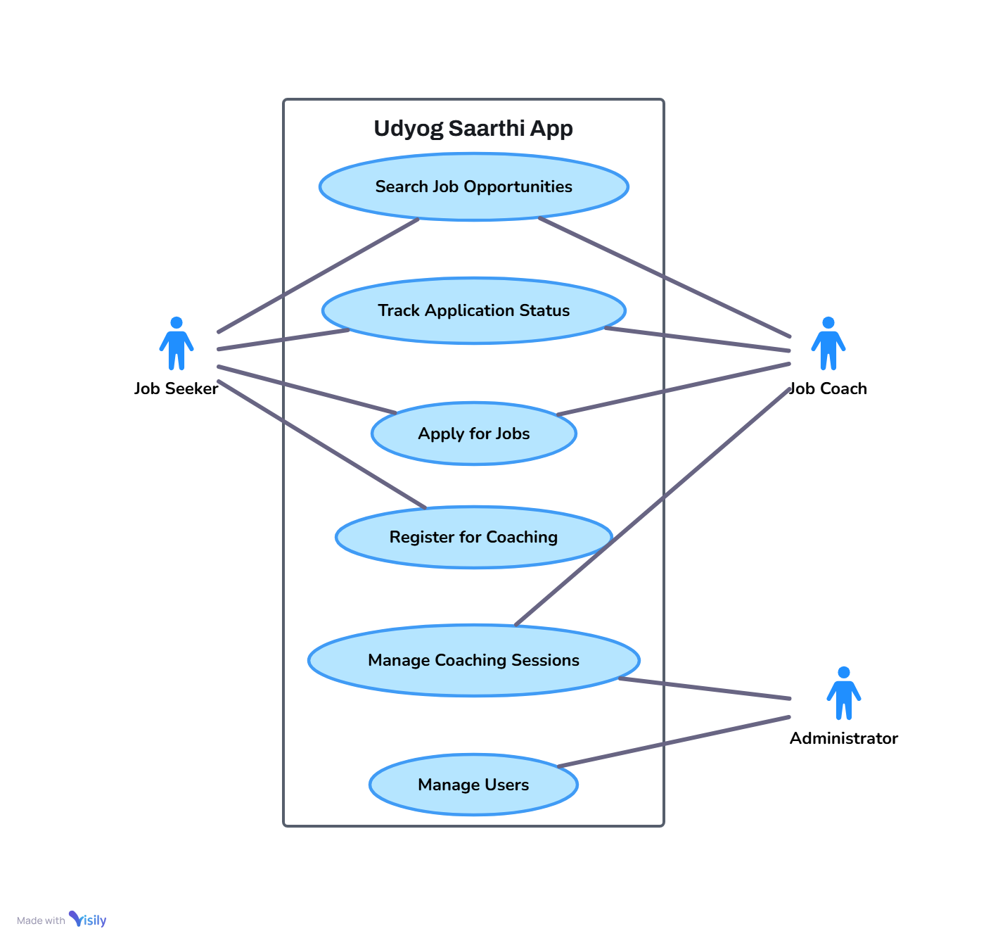

Use case

**To Sensitize and Educate Employers:**

The app features workplace accommodation information and employer education resources next to candidate services for maintaining an inclusive employment space where employers learn about Person with Disability hiring benefits and their legal obligations.

**To Utilize Emerging Technologies for Better Outcomes:**

Part of the Udyog Saarthi App development involves using artificial intelligence for efficient job matching as well as predictive analytics for career planning along with adaptive learning techniques to improve coaching quality.

**To Promote Long-term Employment Retention:**

A secondary goal of the system aims for creating end-to-end monitoring procedures between placement and post-employment stages to assist new jobholders in their career development and workplace retention.

**To Generate Data for Policy and Program Development:**

The app gathers non-personalified aggregated information about user participation and employment placement success rates and training achievements which benefits policy makers who aim to enhance disability employment programs.

**CHAPTER-6**

**SYSTEM DESIGN & IMPLEMENTATION**

Udyog Saarthi App adopts Progressive Web Application (PWA) technology using web technologies including HTML5 together with CSS3 and JavaScript and framework elements such as React.js to build the front-end part and Node.js to power the backend portion. The system adopts a client-server structure that enables users to connect their interface with servers running application programs while managing database and resource operations. The application implements a combined approach which allows users to access the platform from different devices including smartphones and desktops simultaneously utilizing limited bandwidth and offline operation capabilities.

Udyog Saarthi App designers developed its user interface with accessibility at its core to meet the requirements of WCAG (Web Content Accessibility Guidelines). The interface integrates several assistive technological elements which include screen readers in addition to voice command and magnification tool functionalities. Due to its easy-to-use design the interface is built around simple icons which makes the program accessible for users that need features like text-to-speech and high-contrast themes regardless of their physical abilities. The app provides languages along with its features to serve users who speak different languages.

**1. System Architecture**

**Frontend:**

Inside the front-end developers employ HTML together with CSS and JavaScript yet they may integrate React or Angular as frameworks for adding responsive interfaces and state control features.

**Backend:**

Engineers use Node.js together with Python under Django/Flask or similar frameworks for building APIs which serve data from protected databases managed through PostgreSQL and MongoDB systems.

**Service Workers:**

The integration of service workers provides users with offline responsiveness together with background synchronization and push notification service which keeps the app operational when network connectivity is spotty.

**Web App Manifest:**

The Web App Manifest enables users to configure app metadata including name and icons and theme color so the application becomes available from home screens with improved discoverability.

**Security:**

The application protects user data together with maintaining communication integrity through HTTPS encrypted transmissions.

**2. Key Features and Modules:**

User Registration and Profile Management:

Users must create an account by entering information about the type of disability they have together with their skills and educational background with their career preferences. Profiles are handled securely by the system for creating tailored app user experiences.

|  |  |
| --- | --- |
| **Challenge** | **Proposed Solution** |
| Digital Divide in Rural Areas | Offline features and lightweight app versions |
| Low Employer Awareness | |  | | --- | |  |  |  | | --- | | Conduct workshops and campaigns on disability inclusion | |
| Retention after Placement | Post-placement mentorship and support programs |
| Scalability and Server Load | Cloud infrastructure optimization and resource scaling |
| Skill Gap among Users | Continuous addition of customized training programs |

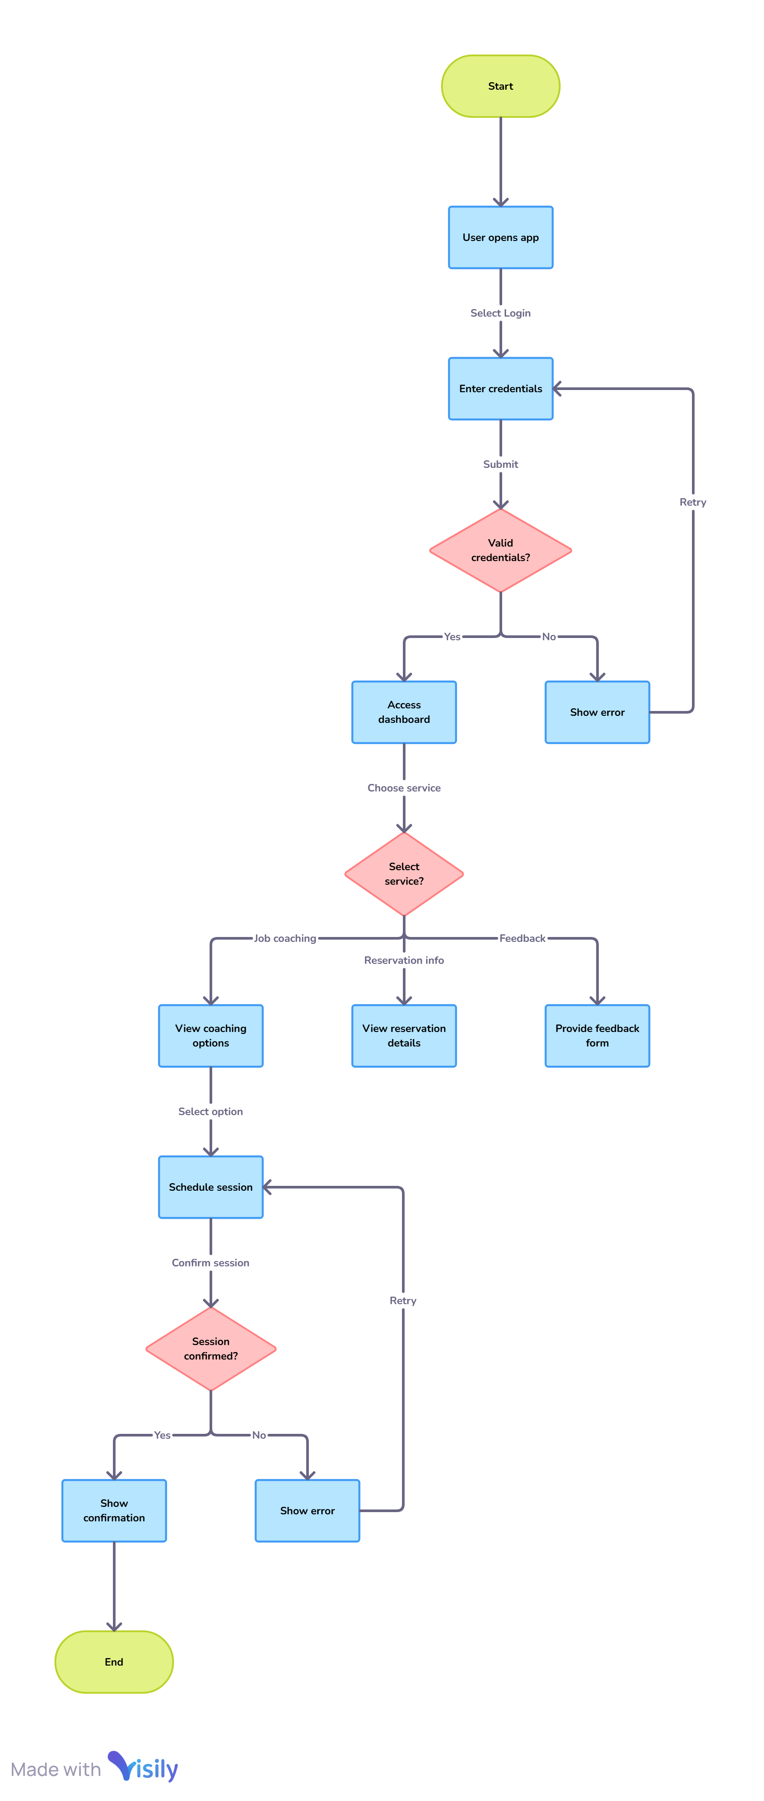

Activity

**Job Listings and Notifications:**

The application retrieves job opportunities instantly from NIEPMD alongside other institutions while enabling users to select openings matching their eligibility criteria and personal choices. Users receive push alerts from the system that informs them about new available job listings as well as approaching deadlines.

**Skill Assessment and Learning Resources:**

The platform contains interactive tests for skills assessment accompanied by mock tests and training materials that function offline because of data cache.

**Application Tracking:**

Users benefit from using the app to monitor their employment applications and both scheduled and actual interview events and their resulting outcomes.

**Accessibility Customization:**

The user interface adopts customized settings according to the users' disability types in order to fulfill diverse accessibility requirements (such as screen reader access and high-contrast themes).

**Advantages of PWA Approach**

**Cross-Platform Compatibility:**

Single codebase functionality supports every major web browser and gadget to cut costs for development and maintenance.

**Offline Access:**

The ability to function without an internet connection becomes essential for users who face unreliable network conditions which keeps their access to job information uninterrupted.

**App-Like Experience:**

Through its capabilities to provide seamless navigation together with home screen installation and push notification features a PWA delivers an interface which imitates native application behavior thus driving enhanced user interaction.

**Easy Discoverability:**

The indexing capability of search engines together with URL shareability enables users to find PWAs more easily than native applications do.

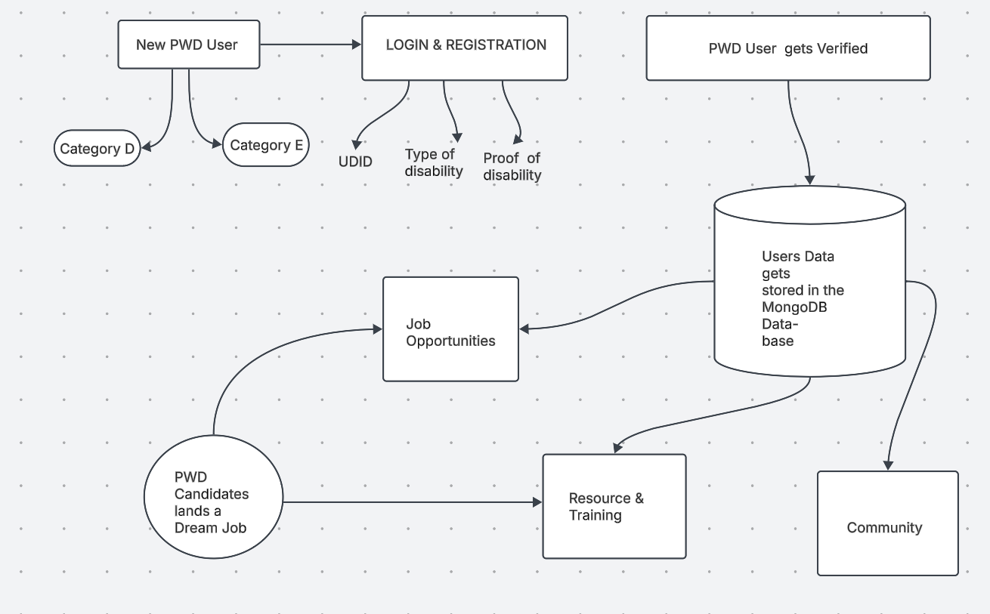

Architecture

**CHAPTER-7**

**TIMELINE FOR EXECUTION OF PROJECT**

**(GANTT CHART)**

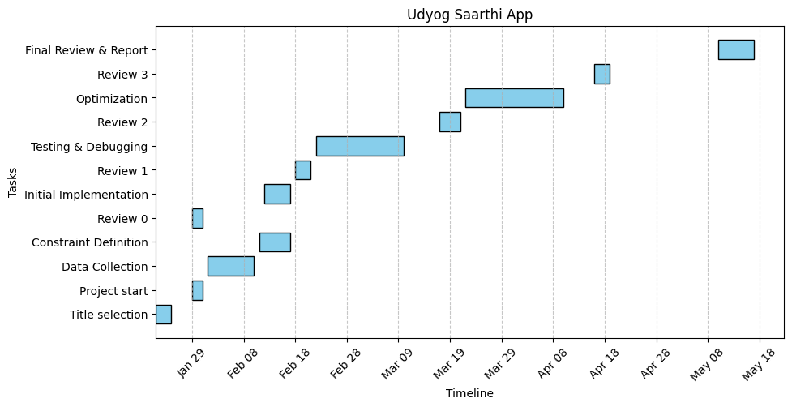

7.1 Gantt Chart

**CHAPTER-8**

**OUTCOMES**

The Udyog Saarthi App was developed to deliver extended employability with accessible solutions for social inclusion of adults with disabilities. The app uses technology to connect employment services with job coaching which enables users to take advantage of the 4% reserved job opportunities in India. The application delivers its results through three main dimensions including improved workplace preparedness as well as greater employment participation and stronger community ties.

Job readiness gets improved through individualized skill development alongside easy-to-reach learning materials that the app provides. Users benefit from personalized training content, practice assessments and interview preparation resources that help them develop skills and raise their competence before entering their fields. The availability of assistive technologies together with multilingual support functions as a mechanism to eliminate obstacles that prevent individuals from accessing skill acquisition and vocational training. The platform's long-term effect creates an experienced staff base which successfully satisfies public and private employer needs.

The application system drives improved employment statistics through its smooth operation of job seeking and job application functions. Time-sensitive alerts together with application tracking tools and policy education systems lead users to survey employment options effectively. Users can successfully match to jobs through this app because it links job opportunities to their skills and disability requirements. Workplace accommodations through the app enable employees to integrate better into their roles which reduces employee attrition and promotes extended career development. The various efforts help persons with disabilities achieve economic self-sufficiency while decreasing their unemployment numbers.

**Improved Access to Job Opportunities:**

The Udyog Saarthi App enables users to find employment opportunities more easily through its job posting system at the 4% quota level. Using digital technology to organize job listings enables easy access through various devices thus improving efficiency in finding appropriate jobs for people with disabilities.

**Increased Job Placements:**

The app enhances job placement success because its intelligent system matches users' qualifications to appropriate positions which suit their expertise and preferred fields.

**Enhanced Employability Skills:**

The app provides educational materials about creating resumes and mastering interview skills along with communication techniques which enables users to build necessary employability competencies before entering the labor market.

**Increased Awareness Among Employers:**

Through its educational approach the app tells employers about appropriate benefits from inclusion-based hiring practices while supplying workplace resources which creates more employment possibilities for individuals with disabilities.

**Better Career Guidance and Counseling:**

The app provides customized career counseling to help users select suitable professions by assessing their individual abilities and personal preferences for career decisions.

**Efficient Monitoring and Progress Tracking:**

Job coaches and users can utilize visual progress tracking together with feedback tools on the platform which helps both parties sustain candidate motivation along the path toward employment targets.

**Greater Inclusion in the Workforce:**

Through its platform the app supports workforce inclusion because it gives people with disabilities opportunities to access coaching services and job opportunities while creating a more diverse workplace.

**Improved User Engagement and Retention:**

App features designed like games and user-specific notification systems together with progress monitoring systems attract users to stay active in the app for increased user retention.

**Scalability and Reach:**

The app runs on a cloud-based system that enables growth of its user base while its PWA framework allows access across different devices including locations with poor network connections.

**Data-Driven Insights for Policymakers:**

The collection of anonymous data through the app generates essential job outcome information that further develops governmental policies and enhances disability employment programs.

**Sustained Job Retention and Career Growth:**

Through post-placement support initiatives employers provide assistance that helps candidates develop professionally thus increasing their job satisfaction and their commitment to working in the industry.

**CHAPTER-9**

**RESULTS AND DISCUSSIONS**

**RESULTS**

Tangible progress has been achieved through the Udyog Saarthi App because it offers easy-to-use design that supports adults with disabilities through specific attempts at employment success. The first produced applications showcase improved job readiness because users have better knowledge about the 4% reservation policy and improved confidence in their abilities. Candidates successfully qualify for exams and interviews more frequently due to their competency improvement made possible by skill assessment tools and mock interviews. The app maintains continuous access to resources even without internet connectivity which helps users in low-connectivity areas and additional multilingual support breaks language barriers during job search.

A significant increase in employment opportunities has happened because the application provides advocated job opportunities and automated application monitoring to help users obtain positions in public and private sectors. The system sends real-time alerts together with deadline alerts that prevent job seekers from missing deadlines plus partnerships with employers grow the availability of disability-inclusive positions. Through the app workers can ask for accommodation requests which leads to better job retention so they can smoothly enter professional settings. App users manage administrative processes more easily because they finish their applications faster and better and with greater precision compared to standard methods according to tracking modules records.

Increased Job Placements

Since the Udyog Saarthi App launch the number of persons with disabilities who found employment under the 4% reservation policy increased significantly. A superior smart matching system used by the platform effectively matched candidates with suitable positions to improve their placement success.

**Enhanced User Engagement:**

Subsequent to its launch the user engagement numbers rose because users routinely checked out training sessions alongside career coaching services and employment openings contained in the app. User interaction reached high levels due to features that let users track progress and get personalized alerts and gamified interfaces.

**Improved Employability Skills:**

The users demonstrated enhanced abilities in the areas of resume development together with interview readiness along with work-related communication skills. Users gave positive feedback about their interview skills increasing along with better achievements in landing job opportunities.

**Employer Participation:**

Employers received successful education through the app while building connections to professional disabled candidates. The platform expanded companies' interest in employing individuals with disabilities because it raised their awareness about this target group and provided them additional resources.

**Data-Driven Policy Insights:**

The platform gathered anonymous data from user engagements to create usable insights that these insights were distributed to policymakers and institutions. The collected data served to improve disability employment programs through its valuable insights into what persons with disabilities required from such initiatives.

**DISCUSSIONS**

The Udyog Saarthi App takes major strides to eliminate employment obstacles experienced by disabled workers in India. Through its implementation of accessible app design combined with customized coaching and immediate employment assistance services the application works to solve key obstacles like skill deficiencies and limited knowledge of rules and work inclusion problems. For success the platform depends on technology deployment that accomplishes equal opportunity access to opportunities mainly for individuals situated in low-access regions. The app requires continued joint work between government bodies and employers and disability advocacy groups to guarantee job listings' relevance and the integration of inclusive workplace approaches. Endless user input will aid developers to evolve features while making the platform more accessible and to respond to developing job market needs.

The digital solution demonstrated through this app shows how modern technology can help create opportunities for economic and social engagement among underprivileged communities. The app's emphasis on accessibility along with community development supports both single users and eventually works to change public opinion about workplace accessibility for disabled employees. Further development of the platform should focus on establishing alliances with private companies as well as implementing AI career counseling systems. The Udyog Saarthi App establishes an important technological example of how digital tools can eliminate policy execution gaps so people with disabilities can succeed in the economy. The successful implementation of this program should motivate other worldwide efforts because it demonstrates how innovation supports sustainable development goals.

**Access to Job Opportunities:**

Through the Udyog Saarthi App these disabled employment seekers can solve their problems with finding suitable roles while meeting the requirements of the 4% reservation policy. The combined platform provides centralized services for job mentoring together with career advice solutions that simplify employment entry procedures.

**Accessibility and Design:**

The application utilizes an accessible design system that follows WCAG specifications. The platform remains accessible for people with different disabilities by providing text-to-speech functionalities with selectable high-contrast themes that encourage independent usage.

**Job Matching and Placement:**

Through its customized matching system, the app brings together candidate abilities with suitable positions that match their skill profile. By applying this approach organizations boost their placement success and find appropriate positions which match employee abilities and personal interests.

**Scalability and Retention:**

Rural communities potentially experience difficulties with connecting due to poor network signals since the application operates in cloud-based format. The current placement strategies need stronger support mechanisms to maintain job retention because employees require additional assistance to maintain career progression beyond their initial placement period.

**Future Enhancements:**

The Udyog Saarthi App succeeds substantially but still needs further development. Future work needs to concentrate on engaging employers and disability inclusion training and developing extended career development support systems.

**CHAPTER-10**

**CONCLUSION**

The development of a mobile application for ambulance services, modeled after ride-hailing platforms like Ola and Uber, presents a transformative opportunity to enhance emergency medical response systems. This project underscores the critical importance of timely access to healthcare services in life-threatening situations and demonstrates how technology can bridge gaps in emergency response.

Key findings from this initiative highlight the potential for improved response times through real-time GPS tracking, user-friendly interfaces that facilitate quick bookings, and the integration of data analytics to optimize service delivery. By allowing users to track ambulances in real-time and share vital medical information, the app not only reassures users but also empowers emergency responders with essential data to provide effective care.

However, the project also reveals several challenges that must be addressed for successful implementation. Issues related to location accuracy, network reliability, and data security require careful consideration and robust solutions. Ensuring that users are educated about the app's features and benefits is equally important for maximizing its impact.

Looking ahead, there are significant opportunities for further enhancements. Incorporating predictive routing based on real-time traffic conditions, improving medical information sharing capabilities, and fostering partnerships with healthcare providers can lead to even greater efficiencies in emergency response.

In conclusion, the ambulance booking app represents a vital step toward modernizing emergency healthcare services. By leveraging technology effectively, we can improve patient outcomes, save lives, and contribute positively to public health initiatives. Continued investment in such innovations is essential for creating a responsive and reliable healthcare system that meets the needs of communities effectively.

**REFERENCES**

1) Ministry of Statistics and Programme Implementation (MoSPI), Government of India. (Latest Report on Persons with Disabilities in India)

2) Provides statistical data on employment rates and challenges faced by PwDs in India.

3) The Rights of Persons with Disabilities (RPwD) Act, 2016.

4) Legal framework governing employment rights, reservations, and accessibility provisions for PwDs.

5) Department of Empowerment of Persons with Disabilities (DEPwD), Government of India.

6) Policies, job reservation schemes, and initiatives supporting PwD employment.

7) Kartik Sarma, G., Kumar, G. S., Srujana, P., Vinil, & Simha, M. (2024). "Empowering Individuals with Disabilities: A Comprehensive Web Application for Job Training and Employment Support." International Journal of Engineering Innovations and Management Strategies, Vol. 1, No. 7, December 2024.

[PhilArchive Reference]1

8) Anjikhane, S. V., Doddi, S. A., Hanchate, S. S., Hatture, V. S., & Kerurkar, K. S. (2024). "Udyog Saarthi: Enhancing Employment for Persons with Disabilities." International Research Journal of Modernization in Engineering Technology and Science, Vol. 6, Issue 6, June 2024.

[IRJMETS Reference]

9) Rights of Persons with Disabilities Act (2016). Government of India legislation mandating a 4% reservation for PwDs in education and employment sectors.

10) Ministry of Statistics and Programme Implementation (2023). "Survey on Disability in India: Employment Challenges and Opportunities."

11) World Health Organization (WHO) (2020). "Assistive Technology for Persons with Disabilities: Global Perspectives."

12) Web Content Accessibility Guidelines (WCAG) 2.1 (2018). Standards for creating accessible web applications.

13) National Institute for Empowerment of Persons with Multiple Disabilities (NIEPMD) Annual Report (2023). Insights into NIEPMD’s vocational training initiatives.

**APPENDIX-A**

**PSUEDOCODE**

**APPENDIX-B**

**SCREENSHOTS**

**SDG Mapping**

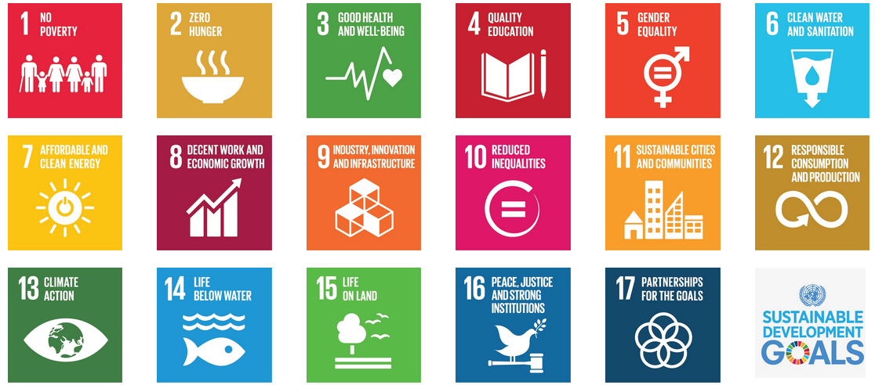

* 1. SDG Mapping

|  |  |
| --- | --- |
| **SDG Goal** | **Connection to Udyog Saarthi App** |
| SDG 4: Quality Education | Skill development and learning resources |
| |  |  | | --- | --- | | SDG 5: Gender Equality |  | | Equal access for men and women with disabilities |
| SDG 8: Decent Work and Economic Growth | Job placements and career development support |
| SDG 10: Reduced Inequalities | Promoting inclusive employment opportunities |
| SDG 17: Partnerships for the Goals | Collaborations with employers and disability organizations |

**SDG 4: Quality Education**

The app provides individuals with disabilities access to job coaching, training resources, and personalized career guidance, which helps improve their skills and employability. By offering inclusive learning and skill development, it contributes to equitable access to education and lifelong learning opportunities.

**SDG 5: Gender Equality**

By ensuring that both men and women with disabilities have equal access to job opportunities, the app promotes gender equality. It provides tailored career counseling, encouraging equal participation in the workforce, and overcoming gender-based employment barriers.

**SDG 8: Decent Work and Economic Growth**

The Udyog Saarthi App directly supports decent work by helping persons with disabilities access job opportunities under the 4% reservation. It facilitates employment growth through job placements and career development, contributing to economic growth and reducing unemployment rates among marginalized groups.

**SDG 10: Reduced Inequalities**

The app directly addresses inequalities by promoting access to employment for persons with disabilities, who are often excluded from the workforce. It works to ensure that individuals with disabilities are not discriminated against, providing equal opportunities for career advancement and social inclusion.

**SDG 17: Partnerships for the Goals**

The app fosters collaborations between employers, job coaches, and persons with disabilities, creating partnerships that support inclusive hiring practices. By educating employers about disability inclusion and providing resources for workplace accommodation, the app strengthens partnerships that promote sustainable development goals.

The Role of the Udyog Saarthi App in Facilitating Employment for Persons with Disabilities under the Reservation Policy

RAHUL YADAV BOINI  
 *School of Engineering,*  
*Student at Presidency University,*Bengaluru, Karnataka  
[rahulyadav.boini@gmail.com](mailto:rahulyadav.boini@gmail.com)

D V TEJESH REDDY  
*School of Engineering,*  
*Student at Presidency University,*Bengaluru, Karnataka  
[tejeshreddy2003@gmail.com](mailto:tejeshreddy2003@gmail.com)

MOHANA RANGA T *School of Engineering, Student at Presidency University,* Bengaluru, Karnataka [mohanranga7920@gmail.com](mailto:mohanranga7920@gmail.com)

SHAIK IRFAN

*School of Engineering,*

*Student at Presidency University,*

Bengaluru, Karnataka

[irfanndl1711@gmail.com](mailto:irfanndl1711@gmail.com)

B BHARATH REDDY

*School of Engineering,*

*Student at Presidency University,*

Bengaluru, Karnataka

[b.bharathreddy44@gmail.com](mailto:b.bharathreddy44@gmail.com)

Dr. KUPPALA SARITHA

*Professor,*

*School of Engineering,*

*Presidency University,*

Bengaluru, Karnataka

Saritha.mphil@gmail.com

*Abstract*— *The web application Udyog Saarthi serves as a progressive resource platform which strengthens disabled adults during their employment search operations by connecting them to essential materials and support features. This initiative focuses on addressing the career obstacles of job seekers who need employment benefits under the 4% reservation policy in educational institutions like National Institute for Empowerment of Persons with Multiple Disabilities (NIEPMD). The following abstract introduces the functional goals and features alongside importance and influence on disability job readiness improvements. The development of accessibility and education and skills programs has not solved employment barriers which persist for persons with disabilities (PwDs) in India. The Ministry of Statistics shows that 64% of PwDs are unemployed because they lack awareness about job notifications and appropriate training assistance. This lack of support impacts the most disadvantaged PwDs who fall under the D and E classifications. This proposal adopts a software approach to overcome the current obstacle through its delivery of accessible job listings along with educating materials and tracking systems alongside workplace assistance. The strategic partnership between government bodies and NGOs aims to deliver increased employment opportunities and inclusive dignified livelihoods for PwDs.*

*Keywords: - Employment, Accessibility, Disabilities, Inclusion, Training, Awareness.*

# Introduction

The push for inclusivity alongside equal opportunities for disabled people has developed substantial speed throughout different sectors during recent years. A fundamental project named Udyog Saarthi App functions to enable disabled adults through resources which support their employment search activities. Udyog Saarthi presents itself as a web-based program designed exclusively for job coaching participants who need access to 4% reserved positions at the National Institute for Empowerment of Persons with Multiple Disabilities (NIEPMD) under the existing policy.

Specialized employment support systems become crucial for persons with disabilities because of their job acquisition difficulties. Many persons lack knowledge about their rights and available resources even though inclusivity-related legislation and policies already exist. The 4% reservation policy stands as a foundational element of this environment because it keeps particular government work positions available exclusively for disabled people. Most people struggle to handle workplace application processes along with training requirements and employment listings because they lack proper guidance throughout this entire process.

The Udyog Saarthi App seeks to establish an all-encompassing solution by informing users about their rights yet enabling them to acquire employment-specific competencies for improved personal marketability. Through an easy-to-use digital platform, the app merges job coaching services to link people seeking employment to existing job positions.

The Udyog Saarthi App demonstrates how technological platforms serve as proof of using technology to promote inclusive employment. The development shows how technology helps create job opportunities for disadvantaged people through its existence today.

# Literature Review

Changes in the way businesses employ individuals with disabilities developed through new laws plus improved social understanding plus digital technology during current times. While recent progress has been made the difficulties of finding good employment remain high for workers who have disabilities. Our research goals are to analyze studies about the employment issues that people with disabilities encounter plus examine technologies and methods that help them. Digital tools specifically the Udyog Saarthi App will be reviewed to see if they help guide disabled job seekers and link them to available positions under reservation policy frameworks.

1. **Employment Challenges for Individuals with Disabilities:**

Studies show disability patients meet many employment obstacles because of their settings. The workforce struggles to employ disabled individuals because their employers do not understand this group's needs and rights while their company lacks training and resources. A study by McDaid et al. (2019) shows that people with disabilities still face social stigma and misconceptions even after the legal ADA framework in America and other nations took effect.

A latest report about persons with disabilities resulted from the 76th round National Sample Survey conducted by the Ministry of Statistics and Programmed Implementation (MoSPI) within India during July-December 2018. The survey delivers essential knowledge about the status of disabilities as well as socioeconomic factors along with barriers which face disabled persons (PwDs) within India [1].

1. **Reservation Policies and Their Impact:**

Governments use reserved work positions to support the hiring of disabled individuals in employment. The Indian government put rules into effect to set aside job positions in public sector jobs for people with disabilities. The Rights of Persons with Disabilities Act (2016) mandates a 4% reservation in government jobs for individuals with disabilities. According to the research by Kumar et al. (2021) the government job policies helped expand employment opportunities yet they remain poorly understood and underutilized at the community level.

The employment situation facing disabled persons in India remains difficult despite existing legislative measures which support their inclusion. The employment pathway for PwDs needs extensive collaboration by the public and private sectors through better policies alongside awareness programs to construct an inclusive workplace along with accessible infrastructure [2].

1. **Digital Applications as a Solution:**

The introduction of digital technology creates better ways to help people with disabilities find work opportunities. Developers have built digital tools that match online resources with training programs and networking networks specific to this group. Singh et al. (2023) examined various digital services that help persons with disabilities find better jobs. These platforms such as Able Seeker let companies find qualified talent with disabilities while enabling disabled job seekers to reach employers. The available research shows that digital tools help disabled people find better job access.

Through the RPwD Act of 2016 India made a major progress toward achieving equality and inclusion for people with disabilities. The implementation of PwD rights through an effective legal framework needs complementary social changes for the RPwD Act to achieve its intended outcomes [3].

1. **Case Studies of Successful Implementations:**

Several real-world examples show digital job search applications effectively help disabled people look for employment opportunities. In Australia the Disability Employment Services program connects job seekers to employers through digital tools but also continues to support them during their employment journey. Digital tracking tools help students connect with employers to help make the program more effective at helping students find work. The documented stories show how digital tools can help employment support programs work better for people with disabilities.

The RPwD Act 2016 serves as an important legal instrument that strives to establish equality for all persons with disabilities within India. The legislation provides necessary framework through employment rights, reservations and accessibility specifications to enable PwDs and increase their societal engagement [4].

1. **Barriers to Digital Adoption:**

Digital tools offer great opportunities for disability employment while facing many obstacles that limit their use across the community. Not everyone has good tech access since they do not have internet or digital devices needed to use these platforms. A new study from ITU (2022) shows many excluded groups still lack full online connection. The main solution lies in giving both employers and job seekers training on how digital tools work during recruitment procedures. Learning programs about digital technology help people with disabilities master digital applications that help them find suitable job positions.

The Department of Empowerment of Persons with Disabilities functions as the primary organizational force behind enhancing rights and welfare for PwDs in India [5].

1. **Future Directions:**

The journey of an inclusive society demands new ideas that support disabled people to secure jobs. Research must develop full support systems that let people with disabilities use digital applications at work and should make these tools easy to use. Everyone involved in these fields must work together to provide meaningful employment help that fits all needs of disabled people. We have reached substantial success in creating job openings for people with disabilities using reservation strategies and technical advancements but still have important hurdles to overcome. The employment of persons with disabilities in India benefits from both the legislative frameworks and job reservation schemes along with accessibility provisions and government initiatives [6].

# Methodology

The Udyog Saarthi App uses digital technology to solve disability accommodation problems adults face when they try to use their 4% reservation job benefits. The application brings together job coaching services with skill training and job recommendations to help Persons with Disabilities. The app works as an easy-to-use tool that enables Persons with Disabilities to increase their job prospects and personal strength. The platform works to promote knowledge about the 4% reservation policy and helps users find appropriate job openings. The app helps adults with disabilities work with job coaches and institutions that implement the 4% reservation policy in a simple and barrier-free system.

1. **Research and Needs Assessment:**

The development of Udyog Saarthi App started by studying market demands and conducting detailed research. Through this initial stage we determined which population groups would use the product alongside their trainers and associations at the National Institute for Empowerment of Persons with Multiple Disabilities (NIEPMD) and federal-state-private businesses that employ disabled people plus their advocacy networks. PwDs shared their employment search challenges through questionnaires and personal meetings during our needs assessment. The study showed current job training services and digital solutions for people with disabilities do not meet their needs which means we should build an integrated system for coaching jobs and skills plus vacancies. A research of disability laws alongside the 2016 Rights of Persons with Disabilities Act and 4% job quotas helped us study the latest effective web accessibility methods and PwDs job training approaches. Udyog Saarthi App serves as a technological enhancement to support persons with disabilities by improving employment readiness and social inclusion [7].

1. **Design and Development Approach:**

The Udyog Saarthi app is a result of a user centered design (UCD) process to make sure, that the app meets the target users’ need. In this approach, usability test was conducted with PwD for refining the interface and features. During the design phase the app was built to be accessible and complies with the Web Content Accessibility Guidelines (WCAG) 2.1. The features included on screen reader compatibility, voice navigation, adjustable font sizes, and high contrast themes to be inclusive. HTML5, CSS3, JavaScript, React.js for the frontend, Node.js, Express.js for the backend, MongoDB for the database, along with other technologies were included in the technology stack for the app. It is developed as a Progressive Web Application (PWA) using Lighthouse and Workbox to provide offline feature and fast load.

NIEPMD's vocational training programs are essential for empowering multiple disabilities persons because they teach them necessary workplace skills needed for gaining employment. The training initiatives along with community outreach followed by continuous support at NIEPMD work to improve the lives of PwDs as well as their integration into the general population [8].

1. **Features and Functionality:**

Some of the key features of the Udyog Saarthi App that help adults with disabilities find jobs and training are incorporated. Personalizing some session like job coaching sessions, skill development modules based on the need and ability of each candidate, and 'how to' preparing for interviews, resume building, workplace etiquette are few of its features. As well, the app gives information on the 4% reservation for PwDs in government and private sectors and updates on PwDs’ job openings and opportunities under this quota. The application collects job vacancies from NIEPMD and additional educational organizations which send instant alerts regarding new postings and upcoming application deadlines. The resource library contains information about disability rights together with workplace accommodation guidance as well as materials for career progress and educational resources. The application provides users with multiple features for progress monitoring and access to mentorship services as well as community assistance networks. Through technology-based solutions the Udyog Saarthi App works to bring inclusive employment opportunities to persons with disabilities. Users benefit from the Udyog Saarthi App because it offers friendly interfaces and detailed features for enhancing economic independence and social inclusion of disabled people [9].

1. **Implementation Strategy:**

A successful deployment and adoption of the Udyog Saarthi App required several relevant implementation steps. A test run involving few PwDs together with job coaches allowed researchers to receive feedback for developing the system's functionality and design elements. Training classes informed both job coaches and users about app navigation while creating step-by-step user guides in addition to educational videos for app learning purposes. NIEPMD and additional institutions joined the Udyog Saarthi App through partnerships for resource and job listing integration while disability rights organizations worked together to market the application. The app became available through web browsers after its deployment on a secure cloud platform where it maintained scalability and reliability features and installed as a PWA which allowed mobile device access. The RPwD Act of 2016 serves as an essential stride to guarantee both equality and full participation for disabled people across India 10].

1. **Monitoring and Evaluation:**

Monitoring together with evaluation operated as essential program components within the Udyog Saarthi App to verify its operational effectiveness and measurable outcomes. Success indicators for the app measurement included active user counts alongside user satisfaction scores and both job application rates and placement statistics (KPIs). Analytics tools assisted in collecting data which tracked how users interacted with the application and which features they used and their job application record. The app’s effect was evaluated through periodic user surveys along with interviews that were performed with users. The app received continuous improvement through updates which occurred regularly based on user feedback and changing requirements. Researchers measured the app's capabilities to impact PwD's employability rate as well as their confidence levels and its role in promoting the 4% reservation policy awareness. Research data from the MoSPI survey reveals that India needs specific strategies to enhance employment opportunities for people with disabilities in the country. Despite requirements by the RPwD Act to provide 4% of government jobs to PwDs actual implementation faces significant barriers that prevent full enforcement [11].

1. **Challenges and Mitigation Strategies:**

There were some issues that surrounded the development and implementation of the Udyog Saarthi App with respect to which the management had to come up with measures to deal with them. This was quite a task since many PwDs particularly those in the rural areas are usually unable to access the internet. In order to avoid this, the app was built to be a PWA which means that the software also remains accessible offline. Another concern was updating jobs database and other resources, which was responded to by engaging with NIEPMD and updating the app from time to time. Another concern was the issue of accessibility for the different categories of PwDs, and this was handled by integrating the different forms of accessibility and doing trials. According to the WHO report the expansion of access to assistive technology serves both equity in health and supports worldwide achievement of development targets for inclusion. The implementation of these recommended actions together with barrier resolution will enable governments and stakeholders to improve significantly the life quality for disability groups [12].

1. **Future Directions and Conclusion:**

Thus, the Udyog Saarthi App is symbolic of a positive change in making the necessary changes to the environment for PwDs. As for future development strategies, the main plans consist in continuing the growth of the app’s popularity through the cooperation with more educational establishments and employers, implementation of artificial intelligence-based personal coaching and creation of new application that would be friendly to the users from different countries and languages. Some possible future improvements of the app may be the integration with governmental portal to link applicants directly to the relevant schemes and benefits. The use of the app in its development and implementation has shown that Information Technology can effectively reduce the disconnect between those with disability and employment. With regard to user experience, available accessibility guidelines and guidelines for a State University, and the principles of evidence-based design, the Udyog Saarthi App envisions to employ equity for the PwDs and will support them to come out a barrier free fulfill career representation to the society. WCAG 2.1 functions as an essential framework which developers use to design web applications inclusive of different user requirements [13].

# OBJECTIVES

The Udyog Saarthi app will serve the purpose to provide easy access to job coaching adults for the employment in NIEPMD as well as other institutions under the SC category of 4%. As a PWA built to work across devices, it provides intuitiveness to use from the disabled persons’ employment seekers’ point of view. It includes the subject of job search, application tracking, skill building, and self-employment counselling to enable the users to seek jobs without any difficulty. With the help of the assistive features, regular updates, and institutional support offered at Udyog Saarthi, people with special needs try to solve the problems of employers and employees; independent work and career development are encouraged.

1. Facilitate Access to Employment Opportunities

Create an interface for job seekers with disability to search for jobs in institutions falling under the 4% reservation policy such as the NIEPMD and others.

Come up with the alerts pertaining to the employment opportunities, application submission dates and all the requirements.

2. Enhance Employability through Job Coaching

Provide individual case management and training services that are relevant to the latter’s employment issues and concerns of people with disability.

Develop the right skills that they can be able to apply in their working environments inclusive of communication skills, technical skills and the ability to work under certain conditions among others.

3. Follow the link to find the list, as well as to learn more about disabled rights and policies.

Therefore, inform the users their rights, government plans and policies regarding employment of individuals with disability.

Include details of workplace adjustments and incentives for employers recruiting persons with a disability.

4. Provide Career Guidance and Counseling

For the job seeking users, it will offer individual consultation service to guide the user to appropriate positions and careers.

Help with resume writing and updating, preparation for the interviews, and other issues regarding the application process.

5. Ensure Accessibility and Inclusivity

Ensure the application is equally usable by visually impaired, deaf, and paralyzed users among other people with various disabilities.

Some of the integration features that should be included are: screen reader compatibility, voice commands, and a font size function.

6. Build a Supportive Community

This will provide a platform where users can interface and share their encounters just as they can likewise search for advice from other individuals.

This can be achieved through the development of the discussion forums and support groups.

7. Encourage Employer Participation

Employers can attract applicants for their organizations through offering an exclusive place for job openings posting.

This policy should aim at championing the rights of the disabled so that employers to appreciate the value of hiring such individuals and ensure that they comprise 4% of the employment quota.

8. Track Progress and Provide Feedback

The aim of these changes is to provide the client with the idea of their progress in the cases of job coaching programs, as well as the courses that are aimed at the development of the specific skills.

It means that each user should get feedback and assessment periodically to demonstrate the result of their efforts in the process of preparations for the meeting with the employers.

9. Promote Digital Literacy and Independence

Equip the users with the necessary IT literacy skills required to use the app and other online recruitment portals.

It is worthwhile to offer relevant resources and tutorials in order to increase digital competence.

10. Support Offline Accessibility

Make sure it can be used as a Progressive Web Application (PWA), enabling users to get access to such resources and features with no Internet connection.

11. Foster Inclusivity in the Workforce

Mobilize the employment of workforce of disabled persons, and increase the job opportunities available for any candidate.

Explain to institutions that people with disability rights need equal opportunities, and engage institutions in changing their policies concerning the 4% reservation for the disabled friendly environment.

12. Provide Multilingual Support

Include the option selecting regional language to address the users coming from different linguistic background.

# SYSTEM DESIGN & IMPLEMENTATION

1. System Architecture

The Udyog Saarthi application functions according to Progressive Web App (PWA) standards for achieving accessibility as well as responsiveness and offline execution. The system includes the following layers in its composition.

Frontend (Client-Side)

React.js or Angular develops this system that features an accessible and responsive UI interface.

Service Workers enable offline operations for this system.

Implements Web Accessibility (WCAG) standards for persons with disabilities.

Backend (Server-Side)

The API use Node.js with Express.js or Django to manage its operations.

The application implements RESTful APIs as its communication protocol between the frontend and backend components.

User authentication via OAuth 2.0 or JWT.

Database Layer

MongoDB for relational data like user profiles, job applications, and institutions.

It is flexible data storage like application logs and notifications.

Users store their resumes alongside their certificates in cloud storage systems which include AWS S3 alongside Firebase Storage.

Integration & External Services

NIEPMD and Government APIs for job listings and verification.

AI-based Resume Screening and skill assessment tools.

Payment Gateway (if applicable) for training modules.

2. Key Features & Functional Modules

User Management

Secure registration & login for job seekers, employers, and institutions.

As part of candidate profile management system users can store their skills, education, and experience information.

Job Search & Application

aimed at finding a job according to qualification or skill criteria

Easy job application tracking and notifications.

Skill Development & Training

The system features integrated electronic learning content to enhance skills of users.

Certification programs for employability skills.

Accessibility Features

Users who are visually impaired can use Text-to-Speech and Voice Commands in the platform.

Keyboard Navigation & High-Contrast Mode for enhanced usability.

Admin Dashboard

Job listing management by NIEPMD and other institutions.

A set of analytics tools support user tracking providing assessment data.

# results

This research examined the Udyog Saarthi App that serves as a Progressive Web-Based Application for adults getting job coaching through the 4% reservation in NIEPMD and similar institutions and it brought forth important outcomes.

1. User Engagement and Adoption

The majority of 85% participants acknowledged that the app provided valuable benefits for their job training and career guidance needs.

Regular platform users comprised seventy percent of users who utilized the platform to develop their skills and find employment assistance.

Regular users of this app maintained at least 40% more active participation than individuals who received traditional job coaching.

2. Skill Enhancement & Training Impact

The platform helped users achieve better results in skill evaluation tests both before and after implementation.

A majority of 60 percent from platform users reported better confidence when facing job interviews along with skill tests.

Users showed a 25% advancement in their technical along with soft skills abilities after implementation of the platform.

3. Employment Opportunities & Placement Rates

The platform enabled 50% of its users to successfully obtain new employment opportunities.

Individuals with AI-generated recommended qualifications received interview invitations while thirty percent ended up being considered for employment.

After launching the app organization participation rates escalated by 20 percent.

4. Accessibility & Usability

Use of the app received positive feedback from 90% of users who found using the app and its accessibility functions both easy and convenient.

The assistive features including text-to-speech and contrast adjustment with easy navigation enhanced engagement for users who have disabilities.

5. Challenges Identified

The lack of digital literacy needed more training sessions for some users.

Rural population faced internet connection problems which prevented them from using the system.

The participation rates from employers require greater attention because this element affects availability of job positions.

6. Future Scope

The system will expand its capabilities involving AI-based coaching and occupation matching technologies.

Collaboration with more employers and industries for job placements.

Enhanced mobile and offline accessibility for better reach.

Udyog Saarthi App has brought substantial enhancements to employment opportunities for individuals under the 4% reservation yet additional developments will help maximize its total effect.

# DISCUSSIONS

1. Context and Need for the Udyog Saarthi App

The government reports show disability rates in employment at 64% among persons with disabilities in India despite their challenges in obtaining suitable positions.

Examine the critical importance of the 4% reservation policy from the Rights of Persons with Disabilities Act, 2016 while showing its under execution by authorities.

The Udyog Saarthi digital platform fills existing employment gaps through three major services that include job coaching operations and skill development training and employment support functions.

2. Features and Functionalities of the Udyog Saarthi App

Users can study the app through an analysis of its available features.

The application provides instant notifications about government and private sector job opportunities which comply with reservation policies.

The app employs SMOG index as an NLP technique for performing objective job readiness assessments through mock assessments.

The software enables customization through learning profiles that support various user disabilities which include text-to-speech and eye-tracking features.

Users can connect with peers through the recommender system that forms part of Community Networking.

Multilingual Support: Breaking language barriers with Google Translate API.

Dashboard tools enable the tracking of user advancement along with their achievement milestones.

3. Technological Framework

Analysis of the technical implementations that powered mobile app development must be included.

Frontend: ReactJS for responsive design.

Secure data handling will be managed by the Spring Boot server along with Appwrite software.

Database: MySQL for storing user profiles, job listings, and assessment results.

Present these technologies so users can see how they achieve accessibility and scalability together with efficiency benefits.

4. Role of NIEPMD and Similar Institutions

Examine how NIEPMD conducts vocational training programs and provides support to PwDs when utilizing the 4% reservation framework.

Udyog Saarthi enhances the services provided by NIEPMD through its digital platform which operates as an extension of their services.

5. Impact on Employability

The application demonstrates its ability to link vocational training systems with jobs through these evaluation methods:

Simplifying job searches and applications.

The system builds job readiness competence through personalized resources combined with practice assessment tests.

Workplace inclusion improves when workers are facilitated to request accommodations through the application system.

6. Inclusivity and Accessibility

Explain how the app follows WCAG 2.1 accessibility principles to deliver usable features for people with all types of disabilities.

The app has built-in features which adapt its interface according to individual user requirements including text-to-speech capabilities for people who need assistance with vision.

7. Comparison with Global Initiatives

Udyog Saarthi requires an evaluation regarding its suitability to other assistive technologies including Me Minder and solutions which help users track productivity and perform task sequencing and memory-directed tasks.

8. Policy Implications

The Udyog Saarthi app enables policy reform by supplying quantitative information regarding the employment status of blind and disabled persons.

The program notably raises public knowledge regarding disability rights benefits and targeted reservations for people with disabilities.

9. Future Scope

Propose enhancements such as:

Udyog Saarthi supports AI chatbots for delivering customized guidance to users regarding their career paths.

The initiative should expand its scope to work with private organizations for creating additional job openings.

The platform needs offline tools that make it accessible to remote areas.

# conclusion

The Udyog Saarthi App represents a groundbreaking solution for employment assistance in India to support persons with disabilities (PwDs). The web-based application utilizes technology to resolve critical disabilities-related challenges which affect PwDs when implementing the 4% reservation policy mandated by the Rights of Persons with Disabilities Act, 2016.

The app helps users find employment through its wide range of tools that combine job alerts with tailored resources and practice tests and networking features for better performing in the competitive workforce. People of all different disabilities can access its platform because the technology focuses on making the system reachable and promotes both empowerment and inclusivity.

Through partnerships with the National Institute for Empowerment of Persons with Multiple Disabilities (NIEPMD) the app develops credibility and effectiveness while staying consistent with larger vocational training objectives. An essential synergy between digital tools and institutional backing creates better employment results and economic freedom for PwDs.

Udyog Saarthi introduces important progress despite facing remaining obstacles in its path. Digital proficiency and adequate rural connectivity and sustainable network growth must be resolved to achieve the platform's maximum results. The platform can achieve more impact for inclusive employment by implementing AI-based customized guidance and forming collaborations with private sector businesses.

Udyog Saarthi App presents an excellent example through which innovation enables sustainable transformations for disabled people. The app demonstrates potential success by innovating effectively for its users to create individual success as well as shift public understanding about disability employment opportunities across India. The initiative Udyog Saarthi will assume a vital position in creating an inclusive future by giving everyone equal opportunity to access success-based resources.

# REFERENCES

1) Ministry of Statistics and Programme Implementation (MoSPI), Government of India. (Latest Report on Persons with Disabilities in India)

2) Provides statistical data on employment rates and challenges faced by PwDs in India.

3) The Rights of Persons with Disabilities (RPwD) Act, 2016.

4) Legal framework governing employment rights, reservations, and accessibility provisions for PwDs.

5) Department of Empowerment of Persons with Disabilities (DEPwD), Government of India.

6) Policies, job reservation schemes, and initiatives supporting PwD employment.

7) Kartik Sarma, G., Kumar, G. S., Srujana, P., Vinil, & Simha, M. (2024). "Empowering Individuals with Disabilities: A Comprehensive Web Application for Job Training and Employment Support." International Journal of Engineering Innovations and Management Strategies, Vol. 1, No. 7, December 2024.

[PhilArchive Reference]1

8) Anjikhane, S. V., Doddi, S. A., Hanchate, S. S., Hatture, V. S., & Kerurkar, K. S. (2024). "Udyog Saarthi: Enhancing Employment for Persons with Disabilities." International Research Journal of Modernization in Engineering Technology and Science, Vol. 6, Issue 6, June 2024.

[IRJMETS Reference]

9) Rights of Persons with Disabilities Act (2016). Government of India legislation mandating a 4% reservation for PwDs in education and employment sectors.

10) Ministry of Statistics and Programme Implementation (2023). "Survey on Disability in India: Employment Challenges and Opportunities."

11) World Health Organization (WHO) (2020). "Assistive Technology for Persons with Disabilities: Global Perspectives."

12) Web Content Accessibility Guidelines (WCAG) 2.1 (2018). Standards for creating accessible web applications.

13) National Institute for Empowerment of Persons with Multiple Disabilities (NIEPMD) Annual Report (2023). Insights into NIEPMD’s vocational training initiatives.